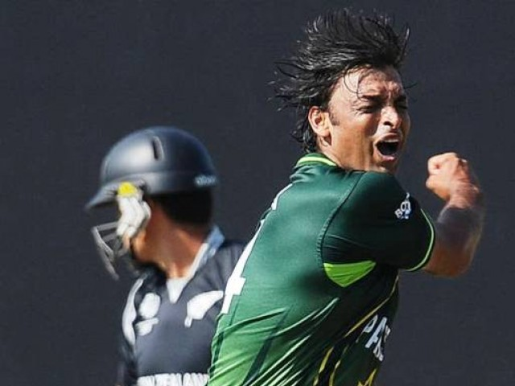

**The dignity with which he took retirement is a rarity in Pakistan cricket.**

**In a touching gesture, the cricketing regions of Islamabad and Rawalpindi have decided to arrange** [**a series of farewell matches**](http://tribune.com.pk/story/150179/shoaib-handed-local-farewell-hopes/) **for their favourite son Shoaib Akhtar.**

**Shoaib – who retired from the game during World Cup 2011 – is one of the most exciting players to have ever stepped onto a cricket field. He is a player who drew contrasting opinions, ranging from being an unfit, undisciplined player to an asset who could have contributed more to Pakistan cricket had the administrators handled him wisely.**

**The fighter….**

**There is no doubt that Shoaib was a temperamental player who regularly got into trouble because of his flare-ups. But having said this, it was the duty of the administrators to ensure that they extracted the best out of this resource.**

**Unfortunately, the bosses at the Pakistan Cricket Board (PCB) were found wanting in their management skills. His frequent injuries – leading to much of the defamation that he received – can be attributed to the fact that unlike his predecessors, Shoaib seldom had the luxury of bowling alongside genuine strike bowlers and hence always had to put in more than his 100 per cent. But he was a fighter; despite encountering a series of fines, bans and injuries, he never gave up and kept fighting his way back into the team.**

**Shoaib, the misfit….**

**Shoaib’s stats do not warrant him a place among the world’s all time greats but his record of 178 wickets in 46 Tests is not all that bad either. However, it was not the wickets that were his principal contribution. It was the attitude that he brought to the team that made him a larger-than-life figure. Unfortunately, the administration failed to cash in on his star power at a time when the country’s cricket needed it the most. They did not appreciate that the team was a much more marketable one with Shoaib in its ranks.**

**Perhaps he was a misfit in the Pakistani team of the new millennium, a team of limited appeal and characterised by defensive leadership. He would have been much more acceptable had he played his cricket a decade back in a team known for its intensity.**

**Dazzling performances….**

**With his frightening pace and vicious swing, during his prime Shoaib Akhtar  was one of the most delightful sights to watch in action. The first time Shoaib came across the great Sachin**

**1**

**Tendulkar, he saw his middle stump uprooted with a deadly yorker. His first encounter with the revered Brian Lara was no less enthralling as a fearsome bouncer crashed into the helmet of the left-handed genius.**

**Ricky Ponting and Steve Waugh became his victims on back-to-back deliveries in Brisbane minutes after Shoaib had made a dramatic late match entry in a four-wheel drive vehicle. He lit up the World Cup 1999 with blistering pace and carried Pakistan to the final. His devastating first spell for the Kolkata Knight Riders left the home crowd and the franchise owner Shahrukh Khan in frenzy. He also has the distinction of bowling the fastest recorded delivery in international cricket. Shoaib was a superstar, a showman, a man who loved the attention and the accolades, a bowler who thrived on the big stage.**

**Shoaib, the warrior….**

**Compared to many of the big names that have represented Pakistan over the years, Shoaib distinguished himself on many counts. Despite his dubious fitness, he never appeared to be someone who would chicken out of key matches; in fact, it possibly goes to his credit that it was always the administration or the selectors who would keep him out of the team.**

**Also, in a country where any cricketer who has spent half a decade or even less in the national team considers captaincy as his birthright, he is an exception. He is possibly the only high profile Pakistani cricketer of his generation who has never vied for the coveted post. He is also among only a handful of Pakistani cricketers who have stood tall amidst all the corruption scandals that have tarnished the image of Pakistan’s cricket over the last decade or so.**

**Last but not least, the dignity with which he took retirement is a rarity in Pakistan cricket where even the greats prefer to fade away rather than gracefully calling it a day.**

**It is a pity that instead of the PCB coming forward, it has been left to the local cricketing bodies to recognize the services of this fast bowling icon; perhaps it is still not late for the PCB to forget about the controversies associated with the enigmatic paceman and celebrate his career for the sheer joy that it brought to millions, the entertainment that he provided to his fans, the star value that he gave to a struggling team and the hope that he gave to a troubled nation.**

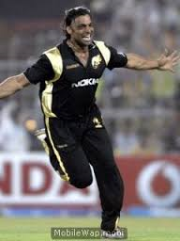

**2**